BRBS business sector association

for recycling crushing and sorting

TAKING ADVANTAGE OF OPPORTUNITIES
Recycling from a CO₂ perspective
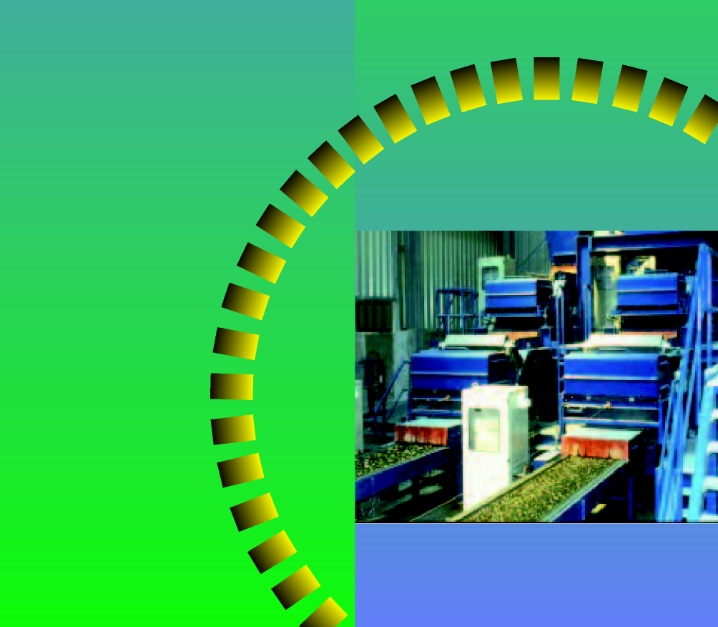

TAKING ADVANTAGE OF OPPORTUNITIES
Recycling from a CO₂ perspective

published by the BRBS, Van Heemstraweg West 2b
5301 PA Zaltbommel, T +31 (0)418 68 48 78 F +31 (0)418 51 54 53

Publisher’s imprint
Text : Business sector association for the recycling crushing and sorting sector (BRBS)
Mr J. Schuttenbeld, chair
Mrs J. de Vries-in ‘t Veld, vice chair
Mr S. Kloetstra, member of the board
Mr J.R. van Veen
Mr G. Gerdes
Mr G. Klein
Mr M. de Vries, director
Layout : CEV-Producties, Rockanje
Printing : Quadraat B.V. printing firm, Spijkenisse
Paper : This publication is printed on recycled paper (Reviva Mega Gloss)
First edition : October 2008
ISBN /EAN : 978-90-812626-2-0

Contents
1. Summary 7
2. Introduction 12
3. Waste stream volumes 2005 → 2020 13
3.1. Present situation 13
3.2 Future situation 13
4. Realistic scenario for volume of combustible residual waste in 2020 15
4.1. More recycling 19
4.2 New opportunities for combustible residual waste 20
4.3 Total shift 21
5. CO₂ reduction 23
5.1 General 25
5.2 Which factors are responsible for the CO₂ reduction? 23
5.2.1. CO₂ reduction through recycling of dry sortable waste 25
5.2.2. Thermal processing with high energy efficiency 25
5.2.3. More recycling of domestic waste 26
5.2.4. Optimising the energy efficiency of waste incineration plants (WIPs) 27
5.2.5. Total CO₂ reductions in 2020 28
6. Recommendations and policy 30
6.1 General recommendations 30
6.2 Stimulatory policy 32
References 34
Appendix 1: Waste volumes 2005 → 2020 38
Appendix 2: Utilisation of secondary fuels and residual waste with high
E-efficiency (>75%) values 39
Appendix 3: Overview of WIPs in European countries 40
Appendix 4: Relationship between E-efficiency and the EU formula (Energy
Efficiency) 41
1. Summary
One of the cabinet's goals is to reduce the emission of greenhouse gases in 2020 by 30% compared to 1990.
In realising this goal, the Minister can count on support from an entirely unexpected corner. The waste and recycling sector alone can account for a reduction of at least 4 Mt CO₂. If policy also focuses more on recycling and residual waste is utilised for energy recovery in dedicated installations, a CO₂ reduction of up to 5.5 Mt could be realised by 2020. This corresponds to almost 10% of the target for the entire Industry/Electricity sector. In the process, more than 50 PJ of extra energy would be generated from residual waste, primarily in the form of heat.
This document produced by the BRBS – entitled “Taking advantage of opportunities” – provides an overview of the most recent insights and studies on the processing of non-hazardous waste materials in the Netherlands. Estimates are made of the CO₂ reduction and energy savings which can be realised via recycling. Domestic waste is also taken into account due to the direct relationship existing between the required waste incineration plant (WIP) capacity and the opportunities for recycling.
In the coming years, the total volume of waste will continue to increase. However, much will change in terms of waste processing.
First signs of a shift
Municipalities are setting ambitious targets for reducing the volume of residual waste from consumers. Their working assumption is a reduction to 150 kg of residual waste per resident by 2012, compared to the present level of 250 kg per resident. This implies that there will be 1.5 Mt less residual waste generated in 2012. The fact that residual waste streams presently consist of 36% kitchen and garden waste, 25% paper/cardboard, and 20% plastics indicates that this is a realistic scenario.
In addition to the fact that large amounts of secondary fuels are utilised in countries outside the Netherlands, for example in German and Swedish energy installations and in cement kilns, relevant examples can now also be cited inside the Netherlands. A thermal processing plant for tar asphalt has successfully carried out trials using energy pellets from residual waste. The paper sector is signing contracts for significant quantities of secondary fuels (several hundreds of thousands of tonnes per year) in the form of sorting residues from building and demolition waste materials. The planned thermal recycling installation in Almere, scheduled to start operating in 2012, will be capable of recovering over 75% of the available waste energy. At the same time, the CO₂ generated in the process will be captured and supplied to the greenhouse farming sector.
Europe
Europe wishes to become a “recycling society.” The introduction of the new Waste Framework Directive marks a significant step forwards. It also provides the Netherlands with a potentially very important export product.
Although the Netherlands can easily comply with the Waste Framework Directive, this does not mean that we can rest on our laurels. Here too, standing still means going backwards, and the same applies to the uncontrolled growth of large-scale processing capacity at the end of the chain in the Netherlands, such as can already be seen in neighbouring countries.
Policy
Policy should focus on encouraging reuse and recycling, supplemented by increasing the amount of energy recovered from non-recyclable combustible residual waste and the utilisation of surplus heat. From the CO2 perspective, this translates into the following:
- recycling results in a greater reduction of CO₂ emissions than does incineration combined with energy recovery;
- non-recyclable residual waste should be thermally processed wherever there is a need for this type of energy;
- the Netherlands should think more in terms of energy needs than in terms of waste removal.
Encouraging recycling
The increased price of fuel and the relative scarcity of raw materials make it very important to encourage the recycling of raw materials and the utilisation of secondary fuels from waste materials.
Imposing a waste eco-tax
The waste eco-tax imposed in the Netherlands on the dumping of waste in landfills and other sites has worked very effectively. The situation in the Netherlands has now progressed to the point where all waste removal processes at the end of the chain (besides dumping, this also includes incineration without significant energy recovery) are discouraged via the imposition of a waste tax. This encourages more useful forms of waste utilisation (sustainable management of raw materials) and results in maximum CO₂ reduction.
In contrast to popular perception, the Netherlands is not leading the pack in this regard. Various other countries – including Sweden, Denmark, Belgium, Austria and Norway – have already overtaken us in this respect. When it comes to thermal processing at the end of the chain, the waste tax charged for such processes could be made dependent upon the E-efficiency (energy efficiency). The most logical option would be to apply this type of tax in an integrated fashion, i.e. to apply it to all combustible waste including domestic waste. Such a policy would make it attractive for municipalities to further encourage waste separation at the source, resulting in only marginal costs.
This type of tax on processing waste at the end of the chain would also further encourage the recovery of valuable components and energy from waste. This in turn would contribute enormously to the sustainable management of raw materials as well as a significant reduction of CO₂ emissions.

TAKING ADVANTAGE OF OPPORTUNITIES
Recycling from a CO₂ perspective

“The business community is taking the Sustainability Agreement, entered into with the Cabinet in 2007, very seriously. I am happy to note that the waste and recycling sector can also be counted upon to support this agreement. This sector has developed into a very innovative one, and by taking measures to support government policy, it will make a substantial contribution to the reduction of CO₂ emissions, the production of energy, and the sustainable use of raw materials. If, within the framework of greenhouse gases, the recycling sector alone succeeds in realising almost 10% of the target assigned to the entire Industry/Electricity sector, then Minister Cramer will be seeing the kind of “action” she talked about on 1 November 2007 at the presentation of the Sustainability Agreement coming from an entirely unexpected direction. This would be a great example of the environment and sustainability benefiting hand-in-hand with economic growth.
The Cabinet should now seize the chance to ensure that recycling in the Netherlands quickly climbs back to the top of the agenda. Reduced CO₂ emissions, intelligent energy production, a new source of raw materials, and a significant new export product will be some of the resulting benefits.
But we will need to change course for this to happen.

Jan Kamminga
Chair of the Environmental Committee of the VNO-NCW (Confederation of Netherlands Industry and Employers)

2. Introduction
The Dutch government wishes to transform the Netherlands into one of the cleanest and least wasteful countries in Europe in terms of energy. In the working programme titled “Clean and Economical: New energy and the climate” the Cabinet describes its ambitions in various areas including energy saving, sustainable energy and underground CO₂ storage. Minister Cramer coordinates this working programme, which is being implemented by a total of seven different ministries.
Minister Cramer:
“We wish to realise a break in the pattern, a shift. This is an ambitious goal, but with the help of the “Clean and Economical” working programme, I am convinced we will be able to realise the targets set for 2020.”
The goals of “Clean and Economical”:
- reducing the emission of greenhouse gases in 2020, in particular of CO₂, by 30% compared to 1990; for the Industry/Electricity sector, this would mean a reduction of 56 to 61 Mt worth of CO₂ emissions;
- doubling the pace of energy savings over the coming years from 1% to 2% per year;
- increasing the share of sustainable energy in 2020 from the present 2% to 20% of total energy consumption.
The BRBS is glad to take up the challenge and enthusiastically supports the ambitions expressed by Minister Cramer. In this report - “Taking Advantage of Opportunities” - the BRBS presents some ideas on reducing CO₂ emissions via recycling. The additional thermal processing of non-recyclable waste in high E-efficiency installations can lead to an even greater reduction of CO₂ emissions as well as energy-saving.
In this study, the BRBS presents its vision with regard to waste processing in 2020. Based on the various trends in the market, opportunities are identified in relation to CO₂ reduction and energy saving.
Hannet de Vries-in’t het Veld, general director of VAR:
“It is no longer a question of whether we will be facing a real scarcity of primary raw materials, but how soon.”
The BRBS defined its overall position on waste processing at the end of 2007 and formulated it in its vision document “Towards the sustainable management of raw materials - recycling as a first step.” On 5 December 2007, this document was officially presented to Minister Cramer of the Ministry for Housing, Spatial Planning and the Environment.

“TAKING ADVANTAGE OF OPPORTUNITIES – Recycling from a CO₂ perspective”
Based on several national and international studies and prognoses regarding the volume of waste streams in the Netherlands, an estimate was made of the potential reduction in CO2 emissions that can be realised by the recycling sector in the Netherlands over the coming decades. This estimate took into account:
- increased recycling;
- optimum thermal processing of non-recyclable combustible medium and high-caloric residual waste;
- improved E-efficiency ratings of WIPs.
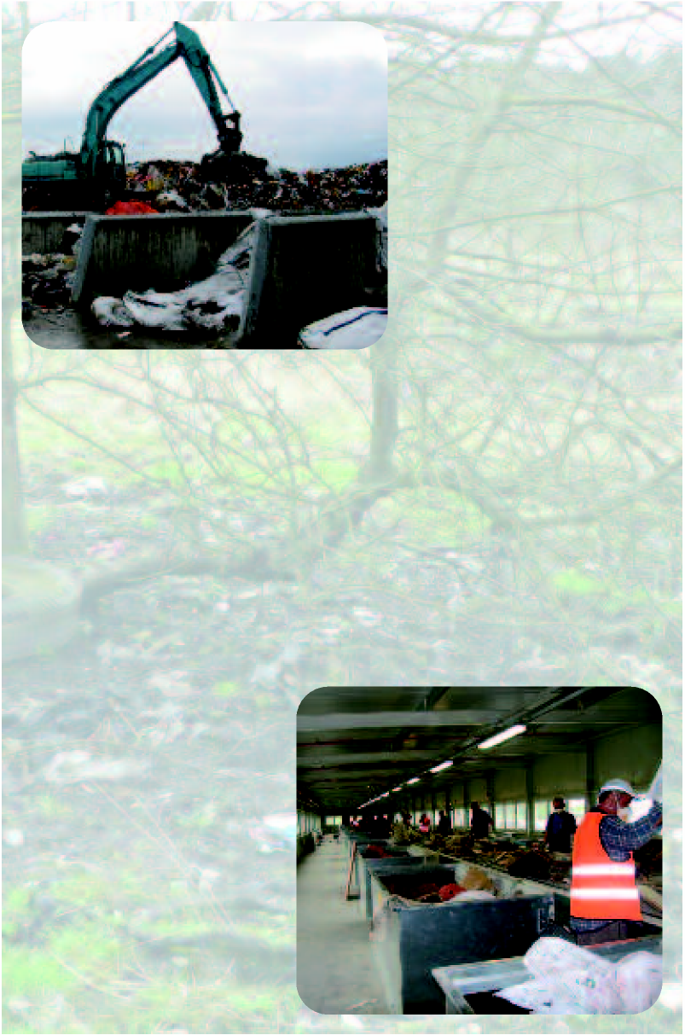
Intergovernmental Panel on Climate Change:

‘Waste minimisation, recycling and re-use represent an important and increasing potential for indirect reduction of greenhouse gas emissions through the conservation of raw materials, improved energy and resource efficiency and fossil fuel avoidance.’ (Ref. 14)

3. Waste volumes 2005 → 2020
3.1 Present situation
In order to be able to plan properly for the effective processing of waste streams, it is critical to know how much waste is now being produced and will be produced in future and what the quality of this waste is/will be.
Adequate information is available on the volumes of the various types of waste produced in the Netherlands. The reports prepared by SenterNovem in particular are valuable in this regard. Based on these reports, the BRBS has collected information (ref. 4) on the volumes of combustible residual waste available from industrial waste, building & demolition waste, and bulky domestic waste.
This information makes it clear that in 2004 approx. 8.43 Mt of combustible waste was still not being put to good use. This amount includes 3.5 Mt of medium to high-caloric waste originating from industrial waste, building & demolition waste, and bulky domestic waste, 1.2 Mt of sewage sludge, and 3.73 Mt of residual domestic waste. Of this 8.43 Mt, 5.5 Mt was incinerated and the remainder was either exported or dumped.
1.38 Mt of combustible waste was dumped in the first nine months of 2007.
3.2 Future situation
The total amount of waste produced in 2004 was 60.4 Mt.
Within the framework of new goals and the LAP (acronym for Dutch National Waste Management Plan) assessment, prognoses were made for the waste volumes to be expected in 2020.
Based on the Strong Europe scenario, SenterNovem (ref. 2) prepared interim prognoses for the various sectors and estimated that approx. 73.3 Mt of waste will be produced in the Netherlands in 2020.
The table below provides an overview of the waste volumes of dry sortable waste materials from 2005 to 2020.
 | 2005  Mt | 2020  Mt
Consumers | 9.1 | 12.3
Industry | 16.6 | 18.5
Commerce, services and government | 5.1 | 5.3
Building & demolition | 23.5 | 30.9

If no changes take place in waste processing patterns by 2020, the total quantity of combustible waste not put to any good use will increase from 8.43 to 10.4 Mt by 2020. This 10.4 Mt will consist of 4.1 Mt (see also appendix 1) of medium to high-caloric waste (residue after processing) originating from industrial waste, building & demolition waste, and bulky domestic waste, approx. 1.2 Mt of sewage sludge and 5.1 Mt of residual domestic waste.
However, opinions on how to deal with waste are clearly changing in the Netherlands. Recycling is an important topic on the political agenda, internationally, nationally and regionally. It is quite likely that large changes/shifts will take place. Waste separation at the source and recycling are becoming increasingly important. Consumption cycles are being closed. In view of the energy issues facing us, increasing efforts will be made to find alternative energy and energy sources. It is only logical to expect that the energy content of the residual waste generated by recycling activities will be recovered more effectively in intelligent thermal processing plants.
One may therefore already conclude that the 10.4 Mt of combustible residual waste referred to above will definitely not be available in 2020.
"In the coming years, waste separation and conditioning on the basis of strict standards to produce various products and fuels will become increasingly important."
Bruno Arts: Sales & Disposal Director, Veolia Environmental Services Belgium
4. Realistic scenario for volume of combustible residual waste in 2020
It is important for the market to have a realistic prognosis for the expected future volumes of residual waste.
The media buzz surrounding Al Gore and the “Cradle-to-Cradle” philosophy has contributed to significant changes taking place in the Netherlands. Thanks to the six pilots involving Cradle-to-Cradle, the packaging covenant, the requirement to separate kitchen and garden waste, and sustainable purchasing, recycling is very much in the spotlight. Municipalities are setting ambitious targets for reducing the volumes of residual consumer waste. Targets are being mentioned of 150 kg of residual waste per resident in 2012, compared to the present-day average of 250 kg per resident. If realised, the volume of residual waste for the Netherlands, with its 16 million residents, would then be reduced from 3.9 Mt at present to 2.4 Mt in 2012!
If we were to separately collect and process half of all the kitchen and garden waste, paper and plastics now still present in the residual waste fraction, the demand for waste processing at the end of the chain would not increase but actually decrease compared to the demand in 2005!
In other words, the separate collection of kitchen and garden waste and paper cannot become a matter for discussion. After all, this is where the first major opportunity lies!
In recent years, the focus on the separate collection of kitchen and garden waste has weakened somewhat. As a result, the amount of kitchen and garden waste collected has decreased by over 10% (ref. 15).
The use of intelligent waste taxation (ref. 16) can lead to an increase in the amount of kitchen and garden waste collected to 200 kg per resident in urban environments as well.
Flanders (6 million residents) has set a target for 2015 of no more than 150 kg of domestic residual waste per resident. In 2005, this amount had already been reduced to 161 kg per resident.
“It's the combination of pricing pressure and environmental awareness that is needed to succeed.”
“The municipality of Apeldoorn is doing its utmost to become an energy-neutral municipality by 2020. Efforts to become a sustainable city should also include efforts to become a waste-free city.
This is also why we aim to reduce the amount of residual waste to 150 kg per resident by 2012. If we take into account that the present 206 kg of residual waste per person still contains 57 kg of kitchen and garden waste, 38 kg of paper and 44 kg of plastics, this should be quite feasible. Our approach here is two-pronged: residents pay only for the residual waste container, and we process kitchen and garden waste, paper and plastics to produce new raw materials.”
Michael Boddeke,
Chairperson of the Environmental Executive Committee for the municipality of Apeldoorn
National Ambassador for Sustainable Government (for implementation of the Climate Treaty)
Based on the above factors and developments, prognoses are presented below for the volumes of residual waste from various sectors. These prognoses are on the conservative side.
The consequences of these prognoses are also described for the total quantity of combustible residual waste and the route which this residual waste will follow in the future.

4.1 Increased recycling
Municipalities
Municipalities will increasingly encourage the separate collection of different waste streams. As a result, the average volume of domestic residual waste per resident will decline significantly. Opportunities are present primarily in the area of kitchen and garden waste, paper/cardboard and plastic packaging. At present (2005), the 3.9 Mt of domestic residual waste being generated still contains 36% kitchen and garden waste, 25% paper/cardboard and 20% plastics.
A realistic scenario would assume that by 2020 at least 50% of these waste streams will have disappeared from the residual waste stream. Based on the Strong Europe scenario, approx. 5.1 Mt of domestic residual waste will be generated in 2020. If 50% of the waste streams mentioned above are prevented from entering the residual waste, this would result in the diversion of 0.92 Mt kitchen and garden waste, 0.64 Mt paper/cardboard and 0.51 Mt plastics, or a total of approx. 2.07 Mt less combustible residual waste. Instead of 5.1 Mt, only approx. 3.0 Mt of domestic residual waste would be generated.
In its briefing of 2008/01, the EEA (European Environment Agency) states: “Improved management of urban waste reduces the emission of greenhouse gases.”
Dry sortable waste materials
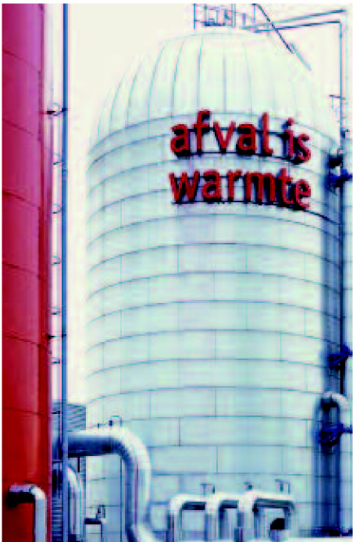
Appendix 1 gives an overview of dry sortable waste materials from 2005 to 2020. If no extra efforts are made in terms of recycling, approx. 4.1 Mt of dry sortable waste is expected to be generated in 2020.
However, as mentioned earlier, we can realistically expect that recycling will account for larger volumes by 2020.
Based on a cautious prognosis, approx. 10% of these waste streams will be recycled by 2020, which would reduce by 0.41 Mt the volume of combustible residual waste generated by industrial waste, building & demolition waste, and bulky domestic waste.

4.2 New opportunities for combustible residual waste
The residual waste streams generated after processing the above-mentioned dry sortable waste materials in recycling plants generally consist of medium to high-caloric products.
By 2020, initiatives must be realised for processing this medium and high-caloric waste. These waste streams will be processed in existing and new (small-scale) so-called thermal recycling installations (TRIs) with high energy efficiency. At present, such waste is primarily still being dumped or used as fuel in thermal installations outside the Netherlands.
Sources for this medium and high-caloric waste include industrial waste, building & demolition waste, and domestic waste. It is difficult to predict how much of this medium and high-caloric waste will actually be utilised in future. For several years, research has been carried out in the Netherlands into the technical and economic feasibility of processing this type of waste in decentralised Dutch installations. As a result, several such applications have been launched in the Netherlands, including the use of tar-containing asphalt as a secondary fuel in a thermal recycling installation and the use of secondary fuels in the paper industry.
In 2012, an installation will also be launched with an E-efficiency of approx. 75%. Besides very high energy efficiency, this installation will also ensure that the CO₂ emissions are fully utilised in the greenhouse farming sector.
Appendix 2 prevents an overview of existing and future high E-efficiency initiatives for processing medium or high-caloric waste fuels.
A conservative estimate is given below for the volumes of such waste which will be processed in this fashion by 2020.
Minister Cramer, in her statement of support for Omrin of 6 April 2008:
“Initiatives such as the residual waste power generating station in Harlingen can make a significant contribution to integrated waste processing and the reduction of greenhouse gases.”
The point of departure in this regard is that approx. 350,000 tonnes will be used as secondary fuels in existing installations. In addition, by 2020, it is assumed that a total of five high-efficiency decentrally located TRI installations will be completed with a capacity of approx. 30,000 tonnes each. They will be fed with medium and/or high-caloric waste fuels with a focus on high E-efficiency in combination with effective utilisation of the heat produced.
By 2020, a total of at least 0.5 Mt of medium and high-caloric waste fuels will therefore be produced and utilised as described above.
It should be noted that over 200,000 tonnes of high-caloric waste are already being utilised in installations outside the Netherlands.
4.3 Total shift
If all the above-mentioned conservative prognoses are realised, then 2.98 Mt less of combustible residual waste will be available for conventional WIPs by 2020 and will be recycled instead.
In other words, a maximum total of 10.4 – 2.98 = 7.42 Mt of combustible residual waste will not be recycled and will therefore need to be processed in a WIP, dumped or discharged. The fraction of this total which is suitable for processing in a WIP will be roughly equal to the quantity of waste materials incinerated in 2004!
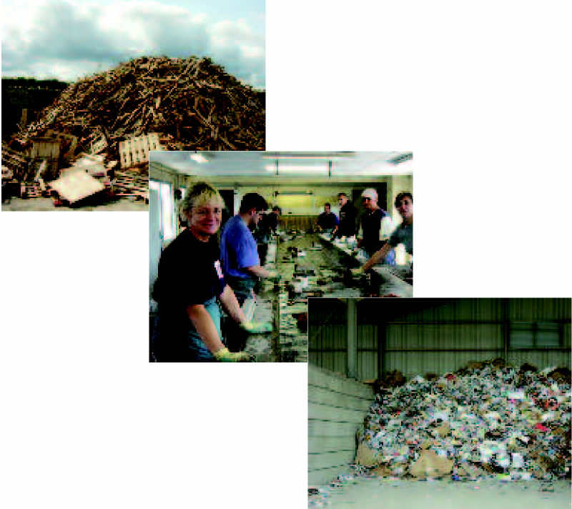

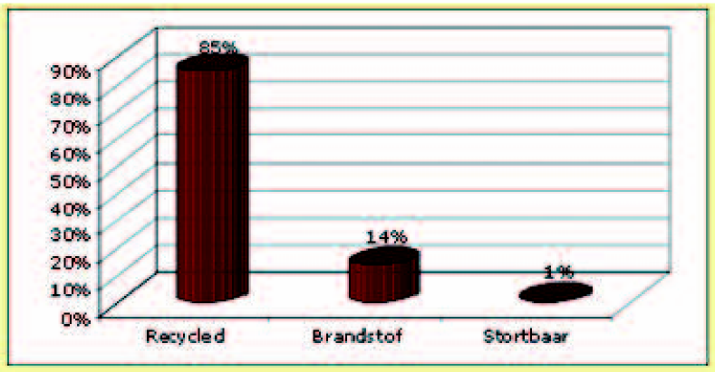
Recycle
Fuel
Can be dumped
5. CO₂ reduction
5.1 General
Based on the changes in the volumes of residual waste to be processed presented above in chapter 4, an estimate is given in this chapter of the CO₂ reduction realised in the waste sector. Various studies from inside and outside the Netherlands have been consulted in this regard. Also consult the references on page 28.
The CO₂ reductions and/or CO₂ emissions prevented in the waste sector can be attributed to the following actions:
- recycling and waste incineration until the present;
- increased recycling in 2020 compared to 2005 of dry sortable waste materials;
- thermal processing of non-recyclable residual waste with high energy efficiency processes;
- increased recycling of domestic waste components in 2020 compared to 2005;
5. Optimisation of the energy efficiency of conventional WIPs.
This report deals only with the additional CO₂ reduction realised compared to the situation in 2005. CO₂ reduction realised via recycling and thermal processing with energy recovery as implemented until now (2005) is not dealt with here.
5.2 Which factors are responsible for the CO₂ reduction?
The overall trend of recent studies into the possibilities of reducing CO₂ emissions in the waste processing sector is quite clear. In all cases, recycling scores significantly better in terms of preventing CO₂ emissions than do dumping and incineration.
An example of this is the recent study into the fermentation of kitchen and garden waste supplementary to composting. Per kilogram of kitchen and garden waste, this results in 400 grams of CO₂ reduction.
Based on the studies consulted, the following reference parameters for CO₂ reduction can be calculated.
Ökopol
Ökopol (ref. 5) studied the effects on CO₂ reduction of domestic waste processing in the 27 EU countries as a whole. Based on this study, one may conclude that if an additional 15% of the total of 255 Mt of domestic residual waste is recycled (65% instead of 50%), the result would be 56 Mt less CO₂ emissions. This works out to approx. 1.5 tonnes less CO₂ emissions per tonne of recycled waste.
Prognos
Based on the Prognos study (ref. 8), for various waste materials, the CO₂ reduction was calculated which would result if recycled raw materials were utilised instead of primary raw materials. It turns out that recycling results in a significant reduction. For example, if 17.4 Mt of building & demolition waste is in part recycled and in part efficiently converted into energy, the result would be approx. 18 Mt less CO₂ emissions. For more detailed information, please refer to the study itself.
CE-Delft
In 2007, CE-Delft carried out a study (ref. 6) into the CO₂ reductions which would result if waste materials were recycled in a WIP instead of simply being incinerated. Based on this study, the SenterNovem website indicates what the CO₂ savings would be for five different waste materials if these materials were collected separately and recycled instead of being incinerated in a WIP:
- Paper/cardboard 2000 g CO₂ per kg
- Kitchen and garden waste 68 g CO₂ per kg
- Plastics 2600 g CO₂ per kg
- Glass 323 g CO₂ per kg
- Textiles 3432 g CO₂ per kg
KEMA
The KEMA institute calculates the amount of CO₂ emissions avoided for the thermal processing of waste materials. This is equal to the CO₂ emissions resulting from the burning of fossil fuels under the same conditions minus the CO₂ emissions resulting from the processes involved in converting the waste materials into secondary fuels. For electricity, the reference value calculated is 592 tonnes of CO₂ emissions avoided per GWh generated. For heat (often generated using gas), the reference value is 201.6 tonnes of CO₂ emissions avoided per GWh generated (ref. 11).
SenterNovem
SenterNovem evaluates projects in which secondary fuels replace fossil fuels in terms of CO₂ reduction.
Their calculations show, for example, that if a secondary fuel consists of 50% organic and 50% plastic material and the energy content is utilised 100%, each tonne of secondary fuel used results in approx. 2 tonnes of CO₂ reduction.
Based on the above studies, the CO₂ reduction is calculated for the scenario presented in chapter 4 and presented below.
5.2.1 CO₂ reduction resulting from the recycling of dry sortable waste materials
In chapter 4, the point of departure was that, by 2020, an additional 10% would be recycled of the 4.1 Mt of residual waste resulting from dry sortable waste materials. Based on the Ökopol study, one may conclude that, roughly speaking, an additional 0.41 Mt of recycling would result in approx. 0.61 Mt of CO₂ reduction. According to the Prognos study, if 0.41 Mt of dry sortable waste materials is in part recycled and in part converted into energy, the result is a reduction in CO₂ emissions of approx. 0.42 Mt when compared to a situation in which only primary raw materials are used.
Based on the reference values calculated by SenterNovem (CE-Delft study), the recycling of 0.41 Mt of dry sortable waste materials would result in a CO₂ reduction of 0.53 Mt when compared to incineration in a present-day Dutch WIP.
5.2.2 Thermal processing with high energy efficiency
The sorted residue from dry sortable waste materials, totalling 4.1 Mt in 2020, is generally of a medium to high-caloric nature with a heat value which is generally higher than 14 MJ/kg. In principle, these combustible residual flows cannot be processed in the present-day Dutch WIPs without additional measures such as “extinguishing” or dilution with low-caloric waste materials etc. An exception is the ARN installation in Nijmegen, which can process waste with an average heat value of 14 MJ/kg.
As indicated in the BRBS 2007 vision document (ref. 4), such materials will be processed in so-called TRIs (thermal recycling installations) or used as secondary fuels. The latter is already taking place in other countries. A TRI is a decentralised (small-scale) installation which can process medium and high-caloric waste fuels with a high energy efficiency (>75%). Such installations aim to realise integrated energy recovery in the form of electricity and heat by using cogeneration systems. By doing so, such installations satisfy local energy needs.
The calculations presented here are based on the energy conversion efficiencies realised in Denmark, i.e. 15 % for electricity and 67% for heat. The fuel used was assumed to have an average heat value of 15 MJ per kg. Based on the KEMA study (ref. 11), this means that each tonne of waste processed results in 0.93 tonnes of CO₂ emissions avoided. In comparison to the WIPs presently in use, this highly efficient thermal processing results in an extra 0.35 tonnes reduction of CO₂ emissions.
In chapter 4, it was estimated that 0.5 Mt of secondary fuels would be processed in this fashion by 2020. This would result in an extra reduction of CO₂ emissions equal to approx. 0.18 Mt. The extra CO2 reduction attributed to that fraction of the waste stream concerned which now still ends up on the dumpsite is not taken into account here.
However, the potential savings are much higher. If all the other sortable waste streams (3.19 Mt) were processed in this fashion, a maximum of 1.12 Mt of CO₂ emissions could be avoided! At the same time, more than 50 PJ of energy would be generated, primarily in the form of heat.
5.2.3 Increased recycling of domestic waste
A key finding is that better management of municipal waste can reduce the emissions of greenhouse gases and, if high rates of recycling and possibly incineration with energy recovery are attained, the net greenhouse gas emissions may even become “negative”. In other words, this could be interpreted in a way that the municipal waste management is contributing to meeting the targets of the Kyoto Protocol. Ref. 13
In section 4.1, it was estimated that, in 2020, an additional 2.07 Mt of the 12.3 Mt of consumer waste would be recycled. According to the Ökopol study, recycling this 2.07 Mt of residual waste could reduce CO₂ emissions by approx. 3.11 Mt.
In accordance with the scheme used in the Prognos study, approx. 2.14 Mt of CO₂ reduction would result due to the savings realised in terms of raw material usage. Using the SenterNovem (CE-Delft study) reference values, recycling the above-mentioned 2.07 Mt of domestic waste would result in 2.63 Mt of CO₂ reduction when compared to incineration in a present-day Dutch WIP. This estimate does not take into account the extra CO2 savings that can be realised by fermenting the kitchen and garden waste fraction of the waste.
5.2.4 Optimising the energy efficiency of WIPs
The primary focus of existing WIPs in the Netherlands is on further optimising the energy efficiency. However, several WIPs focus primarily on the production of electricity. Due to the large scale of Dutch WIPs, it is often difficult to find a market for the heat produced, and the installation of a cogeneration unit, combining heat and electricity production, is therefore not profitable. Depending upon future government policy, more heat will be utilised, although on a limited scale, in the case of large-scale waste incineration.
It should be noted that electrical power stations are continually increasing their energy efficiencies (up to 60% for gas and 48% for coal). This is an additional reason why it is better for thermal waste processing installations to aim for maximum total energy efficiency rather than only for electricity.
The trends described in chapter 4 indicate that the so-called “modified” scenario described in the study carried out by the KEMA at the request of the VA (Association of Waste Companies) is the most realistic one, although it should be noted that a WIP capacity of 8.1 Mt is perhaps a bit high.
Using the “modified” scenario as a point of departure, calculations indicate that in 2020 (excluding the ARN, BKB Delfzijl and REC Harlingen installations), approx. 0.4 Mt of CO₂ emissions can be avoided via extra WIP expansions and another 0.4 Mt of CO₂ via energy efficiency improvements. Overall, WIPs would therefore be responsible for reducing CO₂ emissions in 2020 by a total of 0.8 Mt.
Based on the maximum required WIP capacity specified in section 4.3, calculations were carried out using 7.42 Mt as the WIP capacity instead of 8.1 Mt. By modifying the WIPs presently in operation, it should therefore be possible to avoid roughly 0.73 Mt of CO₂ emissions.
5.2.5 Total CO₂ reductions in 2020
In this report, the impact on CO₂ emissions of the various processing methods for combustible residual waste streams has been evaluated.
The CO₂ reductions were calculated for the realistic scenario described in chapter 4.
As the additional combustible waste that can be recycled is now partly being dumped and partly being incinerated, the CO₂ reduction was calculated by averaging the results obtained on the basis of the Ökopol study reference values and the SenterNovem (CE-Delft study) reference values. For the time being, the Prognos calculations are not taken into account, as the Prognos study does not differentiate between materials recycling and incineration combined with E-recovery.
Based on the prognoses presented in this report, the following CO₂ reductions can be realised:
- Present level of recycling and waste incineration background level
- Additional recycling of dry sortable waste 0.57 Mt CO₂
- Thermal high-efficiency processing 0.18 Mt CO₂
- Additional recycling of domestic waste 2.87 Mt CO₂
- Optimising the energy efficiency of WIPs 0.73 Mt CO₂
Total 4.35 Mt CO₂
Of the total 56 to 61 Mt of CO₂ reduction expected of the Industry/Energy sector, the waste/recycling sector can therefore account for about 7% of the total.
The estimates presented here are on the conservative side, in particular with regard to the processing of medium and high-caloric waste fuels. The CO₂ reduction actually realised could therefore be higher. If the energy from this waste stream is maximally utilised in the form of secondary fuels and (small-scale) thermal installations with a high E-efficiency, an additional 1.12 Mt of CO₂ emissions could be avoided. This would provide a CO₂ reduction of 5.47 Mt, which is almost10% of the target for the entire Industry/Electricity sector. The total amount of energy generated in the process would be more than 50 PJ, primarily in the form of heat.

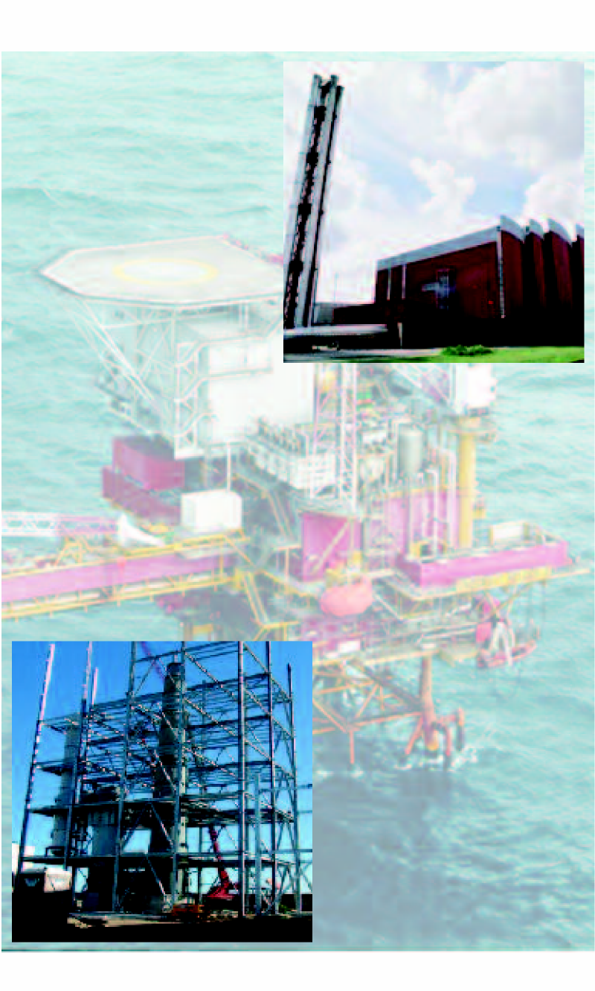
30

KANSEN BENUTTEN
6. Recommendations and policy
6.1 General recommendations
More recycling
More recycling can be recommended from many different perspectives. The present political climate is very favourable for supporting recycling activities with appropriate policies. Current themes such as the sustainable society, closed cycles of raw materials, Cradle-to-Cradle and the reduction of CO₂ emissions all point in the direction of more recycling.
Recycling provides three times as much CO₂ reduction as does incineration in the present-day WIPs.
Europe as a whole has also set targets for recycling. The fact that the Netherlands can easily comply with these targets does not necessarily mean that we can sit back and relax. It is critical to further develop innovative ideas right now and to support them with appropriate policies in order to ensure that we will be prepared for a new wave of sustainable approaches and activities 10 years from now.
“The Netherlands should again define and communicate its ambitions with regard to recycling. The reduction in greenhouse gas emissions that can be realised by simply dealing with waste in an economical fashion is amazing.” Ron Wit, Stichting Natuur en Milieu (Dutch Foundation for Nature and the Environment)
Thermal processing of residual waste
Appendix 3 provides an overview of the average WIP size in various European countries. It is clear that the Netherlands has the largest WIPs by far in all of Europe. This has direct consequences for the opportunities available for marketing the heat generated. The situation in the Netherlands is therefore characterised by a mismatch between the energy potential of residual waste and the opportunities available for supplying heat to the surroundings.
Utilisation of the heat generated results in extra CO₂ reduction. In leading countries such as Sweden and Denmark, the WIPs are smaller by a factor of 5 than in the Netherlands and are also designed and built with a view to supplying heat. The crucial importance of being able to deliver the heat generated to the market is also illustrated by the fact that the countries which have invested in this area are also the ones which score the best in terms of E-efficiency and which receive the highest rating in terms of the European “Energy Efficiency factor” (see appendix 4).
However, it should be noted that the efficiency formula in the European Framework Directive is sometimes incorrectly interpreted. The “Energy efficiency” calculated with the help of this formula actually says nothing about the actual energy efficiency of an installation, although both these variables are strongly correlated.
We may conclude that non-recyclable combustible waste should be processed in thermal processing installations located where there is a demand for heat. This generally requires small-scale CHP (combined heat and power, i.e. cogeneration) installations.
The Netherlands should therefore relinquish the idea of building large-scale waste incineration plants. For generating electricity, it is better to utilise homogeneous fuels which allow high (48% to 60%) energy conversion efficiencies to be realised. Waste is less suitable for this purpose.
One of the conclusions reached by the GUA (Gesellschaft für umfassende Analysen GmbH) (ref. 9) in 2001 was therefore: “All the recovery options studied give an economic benefit to the Society, except the one where electricity generated by waste incineration substitutes electricity generated by a gas fired power plant”.
In future, the focus should be more on processing non-recyclable combustible waste in thermal processing installations in locations where there is a demand for heat.
6.2 Stimulatory policy
Government policy should aim to encourage more recycling and the recovery of more energy from non-recyclable combustible waste. In this context, the discussion in the Netherlands should focus more on energy needs and less on waste removal.
Waste processing and recycling in particular are an artificial market. In the Netherlands, this market became really established only after the first government guidelines prohibiting dumping and introducing taxes on waste came into effect.
It is therefore not possible to completely depend upon market forces in this sector. In actual fact, political decisions determine how waste is processed. Policies which are too liberal will generally encourage an increase in the volume of waste streams in the last links of the waste collection and disposal chain (incineration and dumping).
Encouraging recycling
Obviously, in view of the environmental benefits which result from recycling but which cannot yet be expressed in terms of euros, recycling should be encouraged.
In addition to prohibitions on dumping, a prohibition on burning waste and the use of a “non-recyclable designation” for residual waste would help ensure that valuable raw materials and energy are not shunted off to dumping sites or to incineration plants with a low energy efficiency.
Another way of encouraging recycling is the certification of recycled raw materials and/or the processes involved.
Additional measures are probably also available which would discourage dumping waste or burning it in an energetically inefficient manner and would encourage recycling.
Tax on incineration
Up until now, discouraging waste dumping activities via taxes imposed within the framework of the WBM (Environmental Tax Act) has caused a significant shift towards waste processing methods that focus on earlier links in the waste management chain.
The situation in the Netherlands has now reached a point where waste processing activities at the last link in the chain but one (incineration with or without limited energy recovery) can also be dealt with. The Netherlands is not a leader in this field. Various countries, including Sweden, Denmark, Belgium, Austria and Norway, have preceded us in this respect.
We recommended the introduction of an incineration tax on the incineration of non-recyclable and combustible waste. Such a tax could also take into account the E-efficiency of the installation concerned.
For the sake of simplicity, we recommend that such a tax be applied in an integrated fashion, i.e. on all combustible waste. As many municipalities have implemented policies, or are in the process of doing so, aimed at reducing the volume of residual waste, one would expect that, depending upon the size of the tax, such a measure would provide municipalities with a powerful stimulus for motivating and implementing such policies. The costs involved are expected to be marginal.
Enforcement and granting of permits
A strict enforcement policy is essential to further optimise recycling activities. Now that the last links in the waste management chain have been discouraged via government regulations, transparent and effective enforcement is necessary. As the number of dumping sites and WIPs is rather limited, this should be quite feasible.
As considerable expertise is required when dealing with these types of installations, we would argue, in line with the ideas proposed in the Front Office for Waste, for national enforcement teams for dumping sites and WIPs.
With regard to the granting of permits, the government should take a more stimulatory role. The process of granting permits for new initiatives for improved recycling processes and for processing installations for medium and high-caloric waste streams with a high energy content needs to be executed more quickly and effectively. The authority in charge of granting permits must adopt a more trusting approach for the innovative processes concerned to really get off the grou
References
- Ökopol
The energy efficiency formula of annex II of the waste framework directive, A critical review 5th draft version, June 2006
- SenterNovem
Voortgang Afvalprognoses LAP2 11 Maart 2008
- Tweede Kamer der Staten-Generaal Toekomst milieuwetgeving
Januari 2008
- BRBS
Naar duurzaam grondstoffenmanagement, Recycling als voorportaal November 2007
- Ökopol
CO₂-emission saving potential of EU recycling targets, Seminar on the Waste Framework Directive
November 27th 2007
- CE Delft
CO₂-kentallen afvalscheiding September 2007
- Lezing J. Manders, CEWEP
Energie uit WtE in Europa en NL, Hoe kan NL het beter doen, Confederation of European Waste-to-Energy Plants
18 April 2008
08. Prognos
Potentials of reduction CO₂-emissions within waste and recycling management in Europe, Current situation and future potentials
May 2008

- Gesellschaft für umfassende Analysen GmbH (GUA) Waste to recovered fuel cost-benefit analysis (summary) April 2001
10. Waste-to-Energy and the revision of the Waste Framework Directive, Waste-to-Energy’s contribution to climate protection
February 2008
11. KEMA Nederland B.V
Elektrisch potentieel en warmtepotentieel uit Nederlandse WIP’s voor de periode 2007-2020 Augustus 2007
12. Vereniging Afvalbedrijven
Indicatief overzicht CO₂-reductiepotentiëlen in afvalsector, deelnemersoverleg Schoon en Zuinig – afvaldeel
Januari 2008
13. Municipal waste management and greenhouse gases ETC / RWM working paper 2008 / 1
31 januari 2008
14. Waste Management, in Climate Change 2007
15. Monitoringsrapportage Huishoudelijk afval Resultaten 2005 SenterNovem uitvoering Afvalbeheer
juli 2007
16. Afvalmonitoring in de MARN-gemeenten 2004-2006 MARN oktober 2007

Appendix 1
Waste volumes 2005 → 2020
Within the framework of new goals and the LAP (acronym for Dutch National Waste Management Plan) 2002-2012 assessment, prognoses were made for the waste volumes to be expected in 2020.
Based on a Strong Europe scenario, SenterNovem carried out provisional prognoses for the various sectors concerned.
The prognoses prepared by SenterNovem for LAP-2 are presented in the table below. The table also provides an overview of the dry sortable waste streams in 2005 and 2020 with the exclusion of inert building & demolition waste and waste from the manufacture of inert products.
The figures for 2020 are based on the prognoses by SenterNovem (ref. 2). The distribution over the various waste streams is derived from the BRBS vision document (ref. 4).
Overview of waste streams in 2005 and 2020 expressed in Mt
 |  | Total 2005 | Total 2020 | Combus-tible  2005 | Combus-tible  2020
Consumers | Bulky domestic waste | 2.19 | 3.00 | 0.56 | 0.76
Commerce, services and government |  | 3.42 | 3.55 | 1.71 | 1.78
Construction |  | 3.20 | 4.21 | 1.02 | 1.34
Industrial waste | Wood industry | 0.24 | 0.27 | 0.03 | 0.03
 | Processing paper/cardboard | 0.84 | 0.94 | 0.04 | 0.04
 | Publishers, printing firms etc. | 0.31 | 0.34 | 0.03 | 0.03
 | Processing rubber/plastics | 0.14 | 0.16 | 0.05 | 0.06
 | Processing furniture etc. | 0.27 | 0.30 | 0.06 | 0.07
Total |  | 10.61 | 12.73 | 3.50 | 4.10

Appendix 2
Utilisation of secondary fuels and residual waste with a high E-efficiency (>75%)
Overview of existing and future initiatives for processing medium or high-caloric waste fuels with a high E-efficiency
- Recycling Vijfhoek Flevoland BV
15,000 – 30,000 tonnes of medium-caloric residual waste
completion planned in 2012
- Bentum Recycling B.V.
15,000 tonnes of medium-caloric secondary fuels
- Omrin Harlingen
230,000 tonnes of medium-caloric residual waste
- Paper industry
300,000 tonnes of medium and high-caloric residual waste
- HVC / Dupont
Low-caloric waste with E-efficiency > 75%
“The paper and cardboard industry is a prime example of a high-quality recycling industry. In addition, we are also glad to contribute to a more sustainable form of waste management by utilising the residual waste streams which cannot be recycled into new materials but which are combustible as secondary fuel in a high-efficiency energy installation which produces useful heat and electricity.”
Math Clumpkens, managing director of Smurfit Kappa Roermond Papier
Appendix 3
Overview of WIPs in European countries
Country | Number | total domestic waste tonnes per year | kt incinerated 2005/2006 | Average size in kt per year
Poland | 1 | 9,879 | 40 | 40
Italy | 57 | 32,300 | 3,100 | 54
Finland | 1 | 2,570 | 60 | 60
Luxembourg | 1 | 332 | 100 | 100
France | 128 | 34,947 | 13,600 | 106
Denmark | 30 | 4,007 | 3,500 | 116
Czech Republic | 3 | 3,040 | 400 | 133
Sweden | 30 | 4,513 | 3,500 | 136
Belgium | 18 | 5,010 | 2,500 | 138
Spain | 11 | 25,720 | 1,700 | 154
Austria | 8 | 5,110 | 1,500 | 187
UK | 15 | 35,646 | 3,000 | 200
Germany | 66 | 46,625 | 17,400 | 263
Hungary | 1 | 4,713 | 300 | 300
Portugal | 3 | 4,604 | 1,100 | 366
The Netherlands | 11 | 10,216 | 5,575 | 507

Appendix 4
Relationship between E-efficiency and the EU formula (Energy Efficiency)
The efficiency formula in the European Framework Directive is sometimes interpreted incorrectly. The “Energy efficiency” calculated with this formula in fact says nothing about the actual energy efficiency of an installation, although both are of course strongly correlated. Unfortunately, due to this incorrect interpretation, the European “Energy efficiency” is regularly compared directly to the real energy efficiency. That the European “Energy efficiency” is not the same as the real energy efficiency is caused by the fact that in the European formula the electricity and the energy generated are multiplied by a factor of 2.6 and 1.1 respectively. As a result, the European “energy efficiency” and the real energy efficiency can differ quite a lot depending, for example, on the specific performance parameters of the WIP.
The figure below presents an overview of the average energy efficiency of the WIPs in several European countries (ref. 7). Per country, the electricity and heat
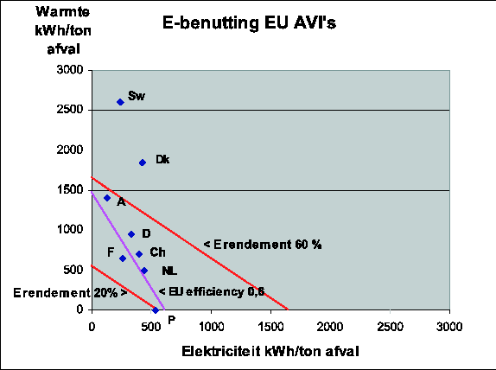
Heat in KWh / tonnes of Waste
E-efficiency of EU WIPs
E-efficiency 60%
E-efficiency
Electricity in kWh/tonnes of waste

produced per tonne of waste is displayed for the average WIP. Lines are also drawn illustrating a European “Energy efficiency” value of 0.60 as well as real E-efficiencies of 20% and 60%.
In leading countries such as Sweden and Denmark, the WIPs are smaller by a factor of 5 compared to the Netherlands. This smaller size greatly increases the opportunities for marketing the heat produced. That marketing the heat produced is the crucial factor is also illustrated by the fact that the countries which have invested in this area have the highest scores in terms of E-efficiency and also score the best in terms of the European “Energy Efficiency.” Installations which have focused in particular on the production of electricity have a low overall energy efficiency rating as a result.
In the table below, the European “Energy efficiency” and the actual energy efficiency for the average WIP is presented per country.
Country European “Energy efficiency” Actual energy efficiency

Sweden 1.30 103%*
Denmark 1.17 82%
Austria 0.70 55%
Germany 0.71 46%
Switzerland 0.68 40%
France 0.52 33%
The Netherlands 0.63 34%
Portugal 0.52 19%
*Actual energy efficiency based on global estimates and assuming an average heat value for Dutch domestic waste (trade, service and government sector) waste of approx. 9.9 MJ/tonne.

